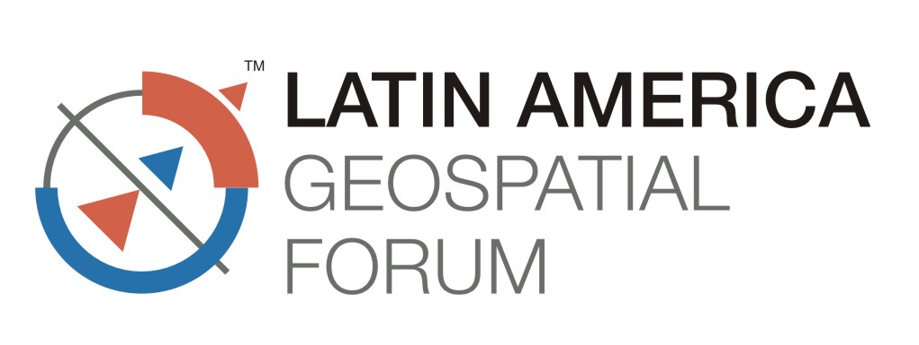


15th – 17th August 2012
SulAmerica Convention Centre, Rio De Janeiro, Brazil

Fascia Name Form  (Compulsory to Standard Shell Scheme Stand Exhibitor) | Return this form to :  Geospatial Media and Communications  A-145, Sec-63, Noida-201301, India  Tel: +91-120-4612500, Fax: +91-120-4612555/666  tarun@geospatialmedia.net

Please indicate on the table below the name of the exhibiting company and stand number to be reflected on the fascia board*. This will be provided in upper case, white standard 100mm-high (4 inches) English alphabet (maximum 24 letters). PLEASE USE BLOCK LETTERS.
Last date: 30th July 2012
COMPANY NAME………………………………………………………………………
REQUIRED FASCIA NAME STAND NO.

* Maximum 24 letters
* Last minute changes on the exhibition floor will not be entertained
The following items are provided with a 3m x 3m Shell Scheme Booth:
a) Walls : Construction of back wall and sidewall partition with 3mm thick panel encased with system profile
b) Fascia : Construction of fascia board with white vinyl sticker cutout of company name and Booth number
c) Electrical : Provision of 3nos. Spot light on walls and 1 on fascia and 1no. 13Amp power socket/230 V single phase power point (not for lighting – only during exhibition hrs.)
The above entitlements cannot be interchanged with other items. If exhibitors do not require any of the items, no refunds will be given.
Customer signature………………………………………………. Date…………………………

